Report to Easington District Council on proposals by the
Coal Authority for the establishment of centralised mine
water pumping and treatment facilities in the District

Paul L Younger

School of Civil Engineering and Geosciences
University of Newcastle

21st July 2003



Scope of this review

This report has been prepared in response to a request from Easington District Council (EDC), first articulated in an e-mail from Mr Tony Forster (an officer of EDC) dated 1st May 2003, and subsequently confirmed in a meeting with Mr Forster and Mrs Janet Johnson (Director of Economic
Development, EDC) on 23-5-2003.

The remit of this review is to critically review the various documents presented to EDC by the Coal Authority (CA), which make a case for the establishment of a centralised pump-and-treat system within the District, to control rising mine waters in the inter-connected complex of former coal workings between the River Wear and the Coast. Particular attention has been paid to the CA's central contention that the "Hawthorn Shaft provides the lowest risk option" [4]♦ for the establishment of such a system. This contention is supported by three reports [1, 2, 3] and a letter [4] sent to EDC by the CA. Essentially, the case made by the CA is that "a formal risk assessment of all the available options" [4] has been made, and that this assessment [3] overwhelmingly favours the establishment of a pump-and-treat system on the site of the former Hawthorn Colliery. This review therefore scrutinises this 'formal risk assessment', paying particular attention to the following points:
- is the assessment thorough?
- is the conclusion that Hawthorn is overwhelmingly the best site sound and well substantiated?
- could other conclusions have been reached which would actually represent a lower overall risk than the Hawthorn option?

Is the Coal Authority's risk assessment thorough and reliable?

It is of the nature of a thorough risk assessment that the many facets of a problem which affect the final choice of a solution be accorded an appropriate level of attention before a conclusion is reached. Clearly, in a 'risk assessment' which concerns the management of mine waters, issues of mine water movement, such as the hydraulic connectivity of underground workings etc, were always going to be major considerations. However, these issues are clearly not the sole considerations. Other issues of major importance include:
- the optimal location of the zone of maximum drawdown in the worked Coal Measures sequence, and the magnitude of that drawdown in relation to the risk of pollution of the overlying Permian aquifer
- the water quality considerations associated with different options for capturing the mine water
- the safe disposal of treated mine water
- the socio-economic context of a long-term mine water pump-and-treat installation
- the risks associated with critical path elements outside of the control of the CA.

The initial report prepared by the Authority was a hydro-geological assesment of the minewater situation. The recommendations of the report were based entirely upon hydro-geological considerations. When this report was first presented to Easington DC it was made quite clear that our preference for the Hawthorn site was on the basis that it provided the optimum solution in terms of hydro-geological control. Further reports were prepared to the specific format and content requested by Easington. At no stage have we been requested to provide any of the additional information mentioned above although it has been discussed at great length in the various meetings held over the last two years. It is unfortunate that Professor Younger did not seek to clarify this prior to providing his report.

It is the author's opinion that none of these additional factors are considered in a sufficiently thorough manner in the documentation provided by the CA. Each of these points is examined in further detail in the following numbered sub-sections.

The issues which govern the optimal location of the zone of maximum drawdown in the worked Coal Measures sequence: these are identified by the CA [1, p. 31] with the following apposite observation: "at the coast the water levels in the Permian and the piezometric head in the workings will be very similar, i.e. at or just above sea level and where water levels in the Magnesian Limestone are depressed by pumping, ie [sic]Thorpe, the flow could be from the mine entries into the Magnesian Limestone if water levels in the workings are allowed to fully recover and outflow". While this observation (and other comments on page 30 of document [1]) accurately identify the major risk associated with mine roadways which entered the Magnesian Limestone Aquifer, the CA claim that "migration through the Coal Measures strata above the mine workings is not considered a significant risk" because of the general efficacy of the former NCB rules for safe mining beneath bodies of water. Experience in other parts of the Durham Coalfield (e.g. south of the Butterknowle Fault, in the Mainsforth area) has shown that the latter is a bold assumption: in that area, there were no mine roadways entered the Aquifer, and yet mine water rebound gave rise to a major plume of non-potable quality water in the overlying aquifer (contaminated principally with sulphate; [5]). This plume has migrated many kilometres to the east since it was first formed in the late 1970s, and it is now approaching (and threatening the continued usability of) the most westerly of the public supply wells owned by the Hartlepools Water Company [6]. Given this experience, which was first brought to light in a research project jointly funded by the Environment Agency and Northumbrian Water Ltd, it is highly unlikely that the latter organisation will be happy with the CA's assumption that protection of the aquifer requires that water levels only be controlled immediately below the decant levels of the mine roadways which enter the Magnesian Limestone.

Mine waters in the area south of Butterknowle Fault were allowed to recover after closure of the mines. The workings in the Low Main Seam at Mainsforth were taken too close to the Permian resulting in a major inrush of 2500 gpm into the workings. (Low Main [J] Mainsforth 2500 gpm [F9/1968]).

The estimated interval between the workings and the Permian was only 100ft (30m) and could be less as it was faulted. This direct connection is almost certainly the route for the contaminated mine water that is entering the Permian, not general flow through strata over a large area. This case cannot be compared with the east of Wear area where there are no workings close to the base of Permian.

While a comprehensive study of the specific risks associated with each of the public supply wells in the potentially vulnerable area in east Durham would be a significant task, a generic analysis is presented below in order to clarify the implications of presuming the aquifer will not be vulnerable to contamination if water levels in the mine workings are allowed to rise above the pumped drawdown levels in the wells, but below the decant levels of roadways entering the aquifer from the various mine shafts. The basic physics of the system to be analysed is outlined in Figure 1. This system can be analysed in order to determine the likely fraction of the total yield of the well arising by upward leakage from the flooded mine workings, by means of the following methodology:
- In plan view, if this circular cone of depression is divided into a large number (100 were used in this analysis) of concentric annulae, each representing a sub-section of the cone of depression with a specific head value and a specific area, then Darcy's Law can be used to estimate upflow from the underlying flooded coal workings.
- Head values for each of the component annulae of a typical Magnesian Limestone cone of depression are obtained by application of the well-known Thiem equation for radial, steady-state flow to a well. The following reasonable parameters (based on the only published synthesis of the hydrogeology of this aquifer [7]) are assumed for illustrative purposes: typical radius of cone of depression around 1 km ; typical well yield of around 5000 m³/d; a transmissivity of about 160 m²/d (adopted by calibration with the preceding two values), which is a conservative but reasonable estimate for this aquifer.
- Head in the coal workings is assumed to be at sea level, which appears to be the level at which the CA currently advocate arresting the water level rise by means of pumping [1,2]. As such, head in the coal workings will only exceed the head in the aquifer in the innermost portions of the cones of depression, as shown in Figure 1. (In this analysis, the zone of potential upflow was found to have a radius of around 130m around the centre of the pumping well).

It is not and never has been the intention to control mine water levels at sea level. This was assessed as the level where the major risk to the Permian starts. Obviously mine water levels would be controlled at a much lower level than this to prevent any contamination of the Permian aquifer. The level at which it will have to be controlled will depend on the hydraulic gradients that develop across the whole area. The levels are likely to be tens of metres below ordnance datum depending on the hydraulic gradients that develop.

The volume of water to be pumped has been assessed at 190 l/sec. This equates to about 20% of the original mine water inflow not 10% as suggested by Professor Younger.

Hawthorn and the borehole both give the same or better opportunity for pumping shallow, less contaminated mine waters as at Dawdon. It is likely that as water pumping becomes established, the chloride levels will decrease as flow paths from the shallow up dip workings become established, allowing the use of reeds and possibly discharge to local water courses. Chloride levels will only remain high if water is migrating slowly through natural Coal Measure strata and picking salts, this is considered unlikely.

- The salinity of the water present in the coal workings is assumed to be equal to that predicted by the CA [1, p. 21], which in terms of chloride concentration is 9000 mg/l. (Chloride is especially useful for the mixing calculations undertaken here, as it is transported conservatively in ground water).

Figure 1 - Schematic cross-section (not to scale) illustrating the presence of a
zone of potential upflow in the centres of the cones of depression of public
supply wells in the Permian aquifer, if water levels in the mine workings
are not maintained at an elevation lower than the maximum
drawdown in these cones.
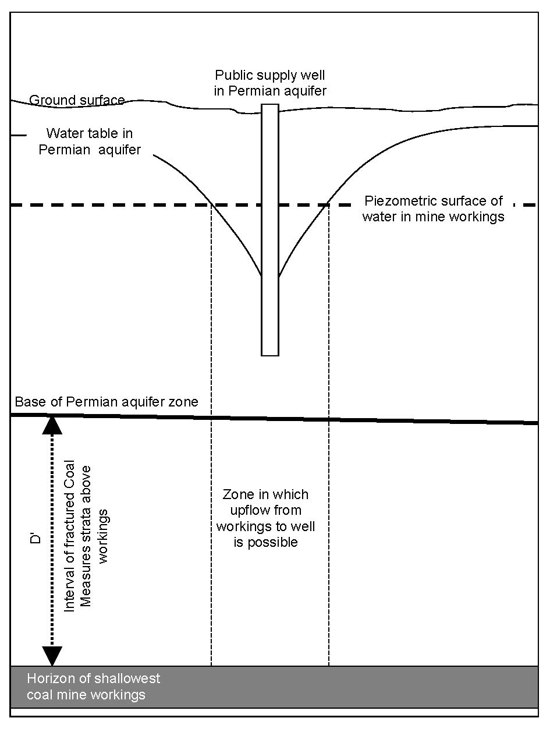
- The thickness of fractured Coal Measures strata separating the flooded mine workings from the base of the Permian aquifer (D') is taken to be 60m, in accordance with the minimum 'stand-off' depth applied during mining beneath aquifers in the UK (cf CA report [1], p. 30). This is a fairly conservative estimate, as the minimum value of D' derived from British Coal cross-sections in the vicinity of Thorpe Water Well (Easington) are actually closer to 120m. On the other hand, the strata in this interval are predominantly sandstone (the High Main Post; [8]), a factor which customarily evokes an increase in the value of D' adopted in practice. To take account of the implications of a 120m cover to Permian, combined with a predominance of sandstone in the sequence, a sensitivity analysis will be applied.
- The hydraulic conductivity of the interval of strata between the shallowest workings and the base of the Permian aquifer is the parameter for which fewest estimates are available. Judging from a recent review of the few published data available for such zones [5], values may range between 0.001 m/d for mudstone-dominated sequences to more than 1 m/d where the sequence is predominantly sandstones (as is the case in east Durham). Given the uncertainties in this parameter, a range of values have been used, and the results of the model of mine water upflow graphed for the entire range (Figure 2).

Figure 2 - Predicted chloride concentrations in a representative public supply well in the Permian aquifer, using the assumptions outlined in the text, for various values
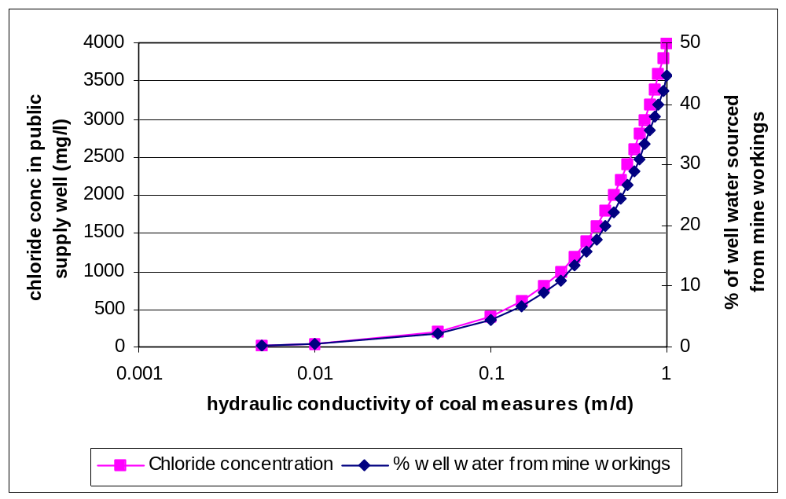of hydraulic conductivity in the fractured strata between the shallowest coal workings and the base of the Permian aquifer (see Fig 1).

It is clear from Figure 2 that the hydraulic conductivity of the fractured Coal Measures strata does not have to be especially high (especially in view of the arenaceous nature of the strata in east Durham) in order for the risk of migration of significant quantities of polluted water to the Permian aquifer to become disturbingly non-negligible. If the more realistic D' value of 120m is applied instead of the 60m mentioned in the CA report [1], together with values of hydraulic conductivity appropriate for fractured sandstone (i.e. 0.1 - 1 m/d), then the percentage of well water derived from the mine workings is still predicted to fall in the range 2 - 22%, with corresponding chloride concentrations of 200 - 2000 mg/l. The outcome of this generalised modelling exercise therefore strongly suggests that it is prudent to proceed with great caution in selecting a design water level to be maintained by pumping in the Coal Measures. In particular, it is likely that the long-term water level in the flooded workings ought to be maintained at or below about -30mOD in order to be sure it is lower than the water table elevation in the centres of the cones of depression of the vulnerable Magnesian Limestone wells. It would also be prudent to locate the point of maximum drawdown in the Coal Measures as near to the coast as possible, since it is here that water levels in the two aquifers will naturally tend to be closest together.

- The vertical permeability of the Coal Measures zone between the shallowest workings and the base of Permian will vary. The permeability of the zone immediately above any long wall workings will be enhanced by the mining. This zone is generally in the order of 40 metres. Above that the vertical flow through the rest of the strata is unaffected and generally a function of the lowest permeable beds and the head difference as Professor Younger describes. Given the presence of low permeability horizons - (seatearths and mudstones) and very small differences in head (a few metres only), the potential flow into the Permian by the mechanism is considered by IMC to be very small. If the permeability of the zone between the Base of Permian and the workings had been high, i.e. >0.1 m/day, the flow to the mine workings would be massive given the extent of the workings and the very large head difference (> 200 metres). Using Professor Youngers’ range of hydraulic conductivity the mine water inflows it would be several orders of magnitude higher than recorded. Even assuming all the water pumped in the mines originated from the shallow workings under the Permian the hydraulic conductivity would only be .0004 m/day, not 0.1 to 1 m/day as suggested by Professor Younger.

There will be some migration of mine water into the Permian via the strata above the workings, but the volume will be small and the risk is not considered to be significant. However, we have already started research work that is designed to have continuous water quality monitoring data from E.A. observation boreholes in the Permian to seek to confirm these views.

- The water quality considerations associated with different options for capturing the mine water: where pumping takes place in a deep shaft or borehole which is open to the mine workings only at depth, then given that mine water quality in East Durham is known to be strongly depth-stratified (with the most saline waters being found at depth) then pumping from a shaft or borehole which is only connected to very deep workings will guarantee that the maximum salinity water will be produced. This is certainly a consideration in relation to the Hawthorn Shaft (only two, deep insets) and the putative 'Hawthorn Junction Borehole' (only one inset, at substantial depth). Insisting on a pumping option which offers no scope for taking long-term advantage of density stratification of mine waters is not a step which should be taken lightly. Only one brief and somewhat oblique comment is made on this matter in relation to the Hawthorn Shaft [1, p. 40]: "the main drawback with Hawthorn is that there are only two shaft insets and these are towards the base of the shaft …. and that the mine water pumped is likely to contain levels of chloride (5000 mg/l) that would not be consented for discharge in a surface water course". The direct correlation between the depth of connections to the workings and the degree of salinity is not spelled out directly, and is not discussed further in any of the CA's reports. In relation to the even more extreme case of the Hawthorn Junction Borehole [3, pp. 7-8], this issue is not mentioned at all.

The assumptions made by Professor Younger regarding the Chloride concentrations in the mine water do not take account of the known layering and the fact that natural chloride levels in the Coal Measures increase logarithmically with depth below surface or the base of Permian. The shallow waters that may flow into the Permian initially via the above method are not going to have the chloride concentrations used by Paul at this stage. However, they are likely to deteriorate as replaced by deeper level waters

- The safe disposal of treated mine water: were coastal treatment works to be constructed, the disposal of the still-saline treated water (from which only the iron will have been removed by the chosen treatment processes) will not cause particular problems. However, treatment at an inland site will require the transmission of the entire treated water make to the sea by means of a pipeline. There are two major technical problems associated with the pipeline option:
- Sizing of the pipeline is essentially a once-for-all decision: it is entirely possible that the design flow chosen for sizing such a pipeline will prove too low. If the water quantity which needs to be handled turns out to be much more than the CA currently estimate (and there are good reasons for believing this to be the case), then either a much larger diameter pipeline would be needed than the CA currently envisage, or else the pipeline, which would entail much greater risks of bursts. The CA's current estimates are based on assumptions of as much as 90% of the former pumping rate having been head-dependent. This is at odds with recent experiences in a number of other abandoned mine systems studied by the author, in which this value has been found to range between 0% (e.g. Blaenant) and 60% (e.g. Whittle Colliery). In East Durham, the known induction of substantial inflows from the Magnesian Limestone (in particular into the workings of Shotton, Blackhall and Horden) strongly suggests that assuming an optimistic value as high as 90% would be reckless. While it would be technically possible to over-specify the pipe so that it could handle any water make, even up to the entire 900 l/s pumped in this area during mining, the cost implications of doing this are enormous: I do not intend to comment on every cost element in the report, just reiterate my comments at the recent meeting. The entire cost of whatever scheme is eventually chosen will be borne by the Authority. The responsibility for justifying that cost will also be borne by the Authority and should not form any part of an independent justification. We are acutely aware of the likely costs and maintenance obligations associated with the pipeline, but equally aware of the costs and maintenance obligations associated with active treatment. Unfortunately Professor Younger does not appear to wish to consider this in respect of Dawdon to provide a balanced debate. the relationship between increasing pipe diameters and increasing cost of the pipe and its installation is non-linear, so that relatively small increments in specified pipe diameter lead to large jumps in total cost.
2. Running a pipeline over this distance for ever and ever, carrying water as corrosive as that anticipated, will inevitably entail substantial risks of leaks. Estimates of these can be made based on water company experiences with high pressure mains; such estimates are not encouraging. The disposal of mine water via pipelines is practised on a much smaller scale elsewhere in the UK. One local example is at the former Addison Colliery (Ryton, Co Durham), where a pipeline has been used to convey mine water directly from the upcast shaft to the River Tyne ever since flooding of the colliery was completed in the 1970s. Although well-documented, maintenance of this pipeline had gradually come to be neglected over the years, until in the late 1990s major leaks developed in the upper reaches of the pipe, leading to local flooding of industrial premises and a public road. Even in that case, where the water was conspicuous on account of its iron staining and there was no dispute about its origins, repairs to the pipeline took several weeks. Treated saline mine waters in the east Durham area will not contain iron and will thus be relatively inconspicuous when leaks commence, and the source of the water may not be established for some time. Thus leaks may develop for some time before they are spotted. Even though the leaks will be a small percentage of the total amount of water going through the pipe, in absolute terms they might be very large, and certainly enough to salinise land, pollute shallow ground water etc. Once this form of pollution has occurred, it is almost impossible to remediate it properly. While a regular regime of pipeline inspection and maintenance could help to minimise this problem, this would be a substantial long-term running cost element, which would need to be taken fully into account in the cost-benefit analysis of alternatives. Overall, the leakage risks associated with long distance pumping of very saline water mean that this option is inherently less sustainable than the alternatives.

The minewater disposal pipeline will be designed with sufficient spare capacity to cater for up to 50% increase in the required pumping rate. The engineering and maintenance of such a pipeline uses conventional methodology. Any leaks that may or could occur on the pipeline would be detectable and would be corrected within a short period of time.
The report refers to a leaking pipeline from Addison Colliery to a discharge at the Tyne. This existing pipeline is in fact routed via a public surface water pipe and to our knowledge has no history of leakage. The nuisance from ochreous minewater that occurred on the Ryton industrial estate at the rear of Miller Engineering works to which the report refers does not relate to a leaking pipeline but to an ochreous water issue on Gateshead Council land at the rear of the works. This has now been collected and piped by the Coal Authority and the nuisance removed. The argument for not progressing the scheme because of the dangers of a leaking pipeline do not bear scrutiny.

Inclusion of socio-economic issues: a number of such issues ought to be addressed in a thorough risk assessment of the case for a long-term mine water pump-and-treat installation. First and foremost is the need for consistency with broader social and economic development needs. Most critically in this regard, recent research published by the Office of the Deputy Prime Minister [9] has definitively demonstrated the degree to which a post-industrial ambience severely limits the willingness of incoming investors to locate new centres of economic activity on a given site. Conspicuous reminders of the 'brownfield' status of development sites (and a pump-and-treat system, however beautified, must fall in this category) lead developers to "require above average returns of they are to invest in regeneration to offset the added risk in areas where market signals are weak" [9]. This requirement manifests itself in greater levels of public subsidy being needed before developers will consider locating on such a brownfield site [9]. The presence of a mine water remediation system on a development site will thus have knock-on effects for the overall level of public investment needed to bring that site into economic use. The implications of these research findings are that the best location of a pump-and-treat plant from the socio-economic development perspective would be at some site where redevelopment has already taken place, and the existing land-uses are not incompatible with neighbouring a mine water treatment facility. At a more specific level, there are issues associated with the pumping and treatment of mine waters which are of considerable relevance to the social acceptability of such operations in close proximity to office-based (as distinct from factory-based) industry. Chief amongst these are issues of visual appearance and odour. With regard to visual appearance, the CA can justly claim [4] that they have "built around twenty of this kind of scheme" and that in these other schemes they have produced "attractive water feature(s) which (have) enhanced rather than detract(ed) from any associated development". However, it is not reasonable to invoke these other operations as suitable analogues for this case. This is for the simple but crucial reason that the salinity of the waters which will have to be pumped in the east Durham area will certainly be far too great to allow the use of attractive wetlands as part of the treatment system.

The report states that salinity of the minewater will be far too great to allow the use of wetlands as part of the treatment process. Current work with wetland plants goes some way to contradicting this statement and further work is being carried out to more clearly establish the range of plants that may be effective in treating saline minewaters. Whether or not a wetland is required will depend on the conditions placed upon the discharge quality. If aeration and settlement is adopted to treat the minewater then ponds of the size indicated are likely to be required but this will need to be confirmed by a period of test pumping. The footprint for the treatment scheme is given as a possible land take requirement and to give an indication of size and visual appearance and for comparative purposes

Hence, rather than developing an attractive landscape feature analogous to the recently-established system of wetlands at Whittle (Northumberland), more intensive treatment processes will be required. These processes inevitably take place in reaction tanks and thickeners which are far more 'industrial' in appearance. On the other hand, these processes require far less land area than wetlands, which means that the CA's repeatedly-stated assumption [1,2,3,4] that only sites with 5 ha of available land will suffice for the establishment of a pump-and-treat operation is simply invalid. With regard to odour, deep, foetid mine waters, such as those which will be pumped in the east Durham area, are almost invariably beset with odour problems arising from the release of hydrogen sulphide gas from the water when it first comes into contact with the atmosphere. As the shaft at Hawthorn lies closer to the other development plots on the Hawthorn site than would the various sedimentation facilities, this factor cannot be simply ignored. There is every reason to suppose that the degassing of H₂S from such a large flow of mine water will, under the prevailing W-E conditions, frequently give rise to unacceptable odours beyond the site boundary. The construction of a high vent stack to mitigate this problem would heighten the 'industrial' appearance of the treatment works. This is potentially a big problem with inland treatment sites; coastal treatment sites benefit from the high winds characteristic of the littoral zone, which give rise to far higher natural dispersion capacity for malodorous gases than is the case inland.

The report states that “deep foetid waters such as those which will be pumped in the East Durham area are almost invariably beset with odour problems arising from the release of Hydrogen Sulphide gas from the water when it first comes into contact with the atmosphere.”

Our experience across many pumping stations shows that this is simply not true. Hydrogen Sulphide is indeed present in many of the mine waters pumped by the Coal Authority. It is dissolved in the mine water and is released when the water is aerated at the cascade. The smell is detectable to the human nose only when within very few feet of the cascade and is dispersed sufficiently to remove any nuisance within 3 or 4 metres of the cascade. No special measures have been required at any of the Coal Authority pumping stations to mitigate against the nuisance. Should special measures be required then the means of alleviating the smell would be to introduce in line scrubbers using caustic or catalytic iron filters dependent upon the concentrations and quantities of Hydrogen Sulphide generated. A high stack would not be the preferred solution.

Of course Hawthorn amongst the potential treatment sites in the East Durham area in having sensitivities relating to neighbouring developments (as will be discussed below in relation to the specific cases of Dawdon and the 'Hawthorn Junction Borehole' sites). However, it is clear that these issues cannot be regarded as sufficiently negligible at Hawthorn as not to merit serious consideration.

- 'Critical path' elements outside of CA control: The further inland any treatment plant is situated the greater are the risks arising from 'critical path' elements of the development project for a pump-and-treat scheme which lie outside of the control of the CA. These risks are mainly associated with the need to rapidly install a substantial pipeline to carry treated water to the sea. Given that this pipeline will have to cross the A19 dual carriageway and the Sunderland-Teesside railway line, complicated negotiations with the Highways Agency and Network Rail would inevitably be required. While these governmental agencies can be expected to be forthcoming with approvals in the fullness of time, the same cannot be said for the many private landowners whose properties lie along the various routes the pipeline might take. Given that many of these landowners are less than favourably disposed to what they still see as "the Coal Board", the length and delicacy of the negotiations which would need to be concluded before the site investigation for the pipeline could even begin (let alone its final design and construction) are likely to be such as to effectively rule out the installation of a pipeline by the CA's deadline of September 2004 [4]. If this option is pursued as the preferred solution, there is every chance that it will come to be implemented too late to save the groundwater resources at Thorpe, North Dalton and other public supply well sites from what the CA rightly terms "irreversible pollution" [4, p. 1]. To predicate the long-term solution for the east Durham mine waters on a major critical path element such as this, which is outside of CA control and also largely outside of the direct control of EDC, introduces an enormous element of risk to the project as a whole. However, the reports provided by the CA [1,2,3,4] offer no discussion whatsoever of this risk element.

The importance and urgency of this project has been a fundamental part of our discussions with Easington over the last two years. We have also made clear that the Hawthorn site would require a considerable implementation period. That is why at our meeting with Easington (attended by the EA) on 14 May 2003 we informed Easington that there was insufficient time to construct Hawthorn without earlier preventative works being in place at Horden prior to September 2004. All parties were therefore aware of this some 2 months ago.

In conclusion, the above discussion makes it clear that the 'risk assessment' provided by the CA cannot be regarded as thorough, and therefore does not provide a sufficiently firm basis for a definitive decision over this extremely important and urgent matter.

How robust is the case for siting treatment facilities at Hawthorn?
From a mining engineering perspective, the Hawthorn site is an obvious choice for a central mine water pumping plant. This is because Hawthorn Combine, the jewel in the crown of the former NCB North East Area, was developed as east Durham's only true 'horizon mine', and as such it had very well-engineered connections on two horizons to the workings of Elemore, Eppleton and Murton Collieries. These three collieries are in turn extensively inter-connected with other mines both to the east (i.e. the coastal pits of Seaham / Vane Tempest, Dawdon, Easington, Horden and Blackhall) and to the west (many old collieries which are inter-connected to varying degrees all the way up-dip to the outcrop zone in the Wear valley). (It is interesting to note that the Hawthorn shaft was never used for dewatering, possibly due to the lack of a suitable receiving watercourse in the vicinity)

Hawthorn was not used for pumping when operational as there was no requirement, water was already being pumped from the interconnected collieries, mainly Murton where existing facilities were in place.

. In terms of mined connections, therefore, the case for Hawthorn Shaft is good, and if mastery of the flow regime in terms only of water quantity was the sole objective, then the case for siting the proposed works at Hawthorn would be as good as any other that could be proposed. However, the overall decision on the optimal site for a pump-and-treat operation must take account of a far wider range of considerations, including:
- the ability of the station to control ground water levels at as low an elevation as necessary in the vicinity of sensitive ground water abstraction sites in the overlying Magnesian Limestone
- the ability of the chosen site to cope with unforeseen increases in the quantity of water needing to be pumped
- the security of the arrangements for safe, long-term disposal of treated (but still saline) waters
- the scope for long-term improvements in water quality at the pumping station
- compatibility with wider socio-economic considerations (an issue of "joined up governance")
- the structural stability of the pumping shaft and the local options for replacing this at some time in the future with a borehole

All of the above issues except the last have already been extensively discussed in Section 2. In summary:
- a pumping station at the Hawthorn site would result in the point of maximum drawdown in the Coal Measures lying 5km inland, rather than in the near-coastal area where maximisation of drawdown would be optimal in order to maximise the protection offered to the sensitive ground water abstraction sites in the Permian aquifer (see 2(I) above)

- the necessity to use a pipeline to dispose of treated water from the Hawthorn site would make the establishment of a pump-and-treat system at Hawthorn subject to significant critical path elements outside of the control of the CA (see 2(v)); it would also inevitably limit the scope for responding to unforeseen increases in the quantity of water needing to be pumped, as well as running the leakage risks associated with long-term operation of the pipeline (see 2(iii))
- as the Hawthorn Shaft has only two insets and both of these are at considerable depth, a decision to pump at this site would condemn the pumping operation to always pumping the most saline mixture of mine water possible (see 2(ii)), whereas pumping at other shafts which have insets to higher seams would hold open the possibility of taking advantage of an eventual 'freshening' of water in the workings as inland mine waters migrate to the coast and stratify above the more saline coastal mine waters
- in terms of compatibility with wider socio-economic considerations, the Hawthorn site is clearly a poor choice, as it conflicts with established re-development plans in an area which is badly in need of new jobs following the end of the mining industry, both through the presentation of a stark reminder of the previous industrial history of the site (a factor known to deter potential investors [9]) and by the potential problems associated with H₂S odours (see 2(iv))

With regard to the structural stability of the pumping shaft, this issue equally affects all similar options. While the Hawthorn Shaft is about 50 years old, whereas the other shafts considered by the CA as possible pumping stations are closer to 100 years old, it is important to note that:
- even Hawthorn Shaft is already well outside of its original design life (nominal 25 years) The design life of a shaft is relevant if it is used as a conduit to transport men and materials into a mine. I fail to see how this is relevant in this situation.
- all of the shafts under consideration were subject to similar inspection and maintenance programmes right up to the time of closure
- the mass concrete lining of Hawthorn Shaft was not specifically designed to resist corrosion by very saline mine waters during an extended period of use as a pumping shaft, and there is no particular reason to assume it will perform better in this role than will the combined steel tubbing / concrete back-grout linings typical of other shafts in the district (e.g. Dawdon [10]).

It is again interesting to note that this issue is found amongst the drawbacks of Hawthorn but fails to figure in the Dawdon section, particularly bearing in mind that the shaft at Dawdon is twice the age of its Hawthorn equivalent.

Concerns over the long-term integrity of the shafts as structural features inevitably leads to the conclusion that they will, in the long-term, need to be backed-up (and eventually replaced) by purpose-drilled boreholes. At Hawthorn, such a borehole would need to be drilled to intersect the two 'horizon' loco roads which inset to the shaft. Hitting two such insets in a single borehole would be a considerable challenge. At other sites, a back-up borehole would likely have more inset roadways to aim for, or it could even aim for panel main / tail gates close to the shaft. The Hawthorn site is possibly less attractive than alternative sites on these grounds.

Any boreholes drilled to replace an open shaft that has failed would be into single roadways with good connections. A replacement borehole at Hawthorn would only go to the Low Main horizon whereas a replacement at Dawdon would have to go to the deeper High Main or Maudlin insets dependant on connections.

The only robust reason for choosing Hawthorn ahead of other sites therefore appears to be its status as a former horizon mine. Yet even this is not beyond question. It is in the nature of horizon mines that the principal roadways connecting distant workings to the shaft are long cross-measures drifts. By their very nature, these roadways must cross substantial intervals of mudstone, siltstone etc which may not prove very stable after rebound. If a roof fall blocks a major roadway in a conventional coal mine, water will often bypass the blockage by flowing through the ?face halt positions of adjoining panels. Where reliance is placed on a cross-measures drift, then no matter how well engineered it may originally have been, there is less scope for bypass flow in the event of a roof fall than would be the case in a conventional mine. This is well illustrated by the case of Woolley Colliery, West Yorkshire, which was also developed as a horizon mine. In the early period after completion of rebound, pumping of water from this colliery served to control water levels to the west, in which direction a substantial cross-measures 'horizon' roadway was known to extend. However, after blockage of this roadway occurred, insufficient bypass flow developed to avoid back-up of water to the west, eventually necessitating auxiliary pumping at Caphouse. This risk is therefore a real one, but it is not mentioned in the reports provided by CA [1,2,3,4].

Blockages and restrictions in flow do occur in underground roadways A restriction in flow has occurred in the Caphouse to Woolley connection and a total blockage has occurred in the roadway between Monk Bretton and Barnsley Main. It should be noted that the connections were not part of the initial mine design, but added much later, in both cases for the purpose of mine water drainage and not as part of the basic mine infrastucture. In both cases, the blockage has occurred where the roadways pass through major faults and their associated fracture zones. The mechanisms behind the blockages are believed to be related to the fact that the faults are boundaries for major stress changes underground. The lack of other drivages through the faults would tend to support this.

Roadways in seam are generally poorly supported are more highly stressed due to the mining around them and have limited life. Cross measure roadways are designed for long life and generally better supported as they were intended as part of the “long term” infrastructure accessing the mine.

Wherever pumping is carried out, there is a risk of poor connectivity between the different mine blocks.

The most stable, open roadways in coal mines are cross measure drifts. The nature of the strata
usually associated with coal seams is primarily mudstones, often with a seatearth texture. The
principal areas of poor connectivity are the dammed connections between the coastal collieries of
Dawdon, Easington and Horden. The single roadway connecting Easington and Horden us
dammed, but known to be leaky. There is then only one roadway connecting Horden with Shotton
and this is from goaf to goaf. A much riskier proposition than any cross measure roadway.

In conclusion, the case for siting mine water treatment facilities at Hawthorn is not robust. Having extended the overall risk analysis beyond the narrow range of factors considered in the reports presented by the CA, a plethora of crucial issues has emerged which have thus far been entirely overlooked. When these issues are scrutinised, the case for choosing the Hawthorn site ahead of all other alternatives is seen to be weak.

Is there an alternative option with a better overall risk-profile?

The CA have considered alternative locations for a possible pump-and-treat system in a specific report [3]. One of the key issues used as a driver in that report was the availability of sufficient land for a very large wetland system. However, since it is now clear that wetland technology is simply inapplicable (see earlier comments)to the saline waters expected to be pumped in east Durham, this driver simply disappears. More intensive methods of mine water treatment require far smaller land-takes than do wetland treatment, and when this is taken into account, almost all of the sites considered in the CA alternative options report [3] are suitable in terms of availability of sufficient land for treatment. The search for the optimal location for a pumping system can therefore be constrained by a narrower range of issues (albeit this range is still wider than that considered in [3]), amongst which the following are paramount:
- the selected site must be amenable to rapid development, and must therefore be largely free from 'critical path' elements outside of CA control, such as the need to obtain easements for a long pipeline over numerous properties
- the proposed land-use ought to be compatible with existing land-use in the vicinity
- the selected pumping shaft / borehole must have very high connectivity both to a large number of seams (including the shallowest) and, via adjoining collieries, to the majority of mine workings in the east Durham area
- disposal of treated mine water must be straightforward.

Re-reading the alternative options report [3] with the above 'filters' in place, one is rapidly forced to the conclusion that the optimal location for a pump-and-treat system in the east Durham area would be at the Dawdon Colliery site. Briefly, the reasons for dismissing the other options discussed in the options report [3] are as follows:
- Sherburn Hill, Nicholson's and Lumley 6th are far too distant, and located too high above likely decant features within the workings, to facilitate their use to control rising mine waters in the east Durham area. In the event that their decant pathways towards the coastal ponds do not prove sufficiently transmissive, they could be used to prevent localised discharges to the River Wear. If the decant pathways are transmissive, these stations could be used (as they were formerly) to minimise the eastward flow of mine water from the shallow workings near outcrop, though this is unlikely to become an attractive option on either environmental or economic grounds.
- Horden and Easington: although these pits were considered likely to have sufficient connectivity to the surrounding pits to justify substantial pumping to prevent inrushes during mining, this connectivity is not so good as to make them reliable locations for pumping to control mine water levels throughout the east Durham area. (See section 5 for a discussion of whether auxiliary pumping is likely to be needed at these shafts).
- The Hawthorn Junction Borehole proposal suffers from six major disadvantages:
- only one inset is proposed, at substantial depth, entailing the same problems in relation to long-term water quality as at Hawthorn (i.e. pumping from near the base of the mine water column) and entailing the risk that collapse of roadways adjoining this single inset would make the borehole unusable; (see above)
- the establishment of a suitable borehole, of such a depth, to a tight timetable is a substantial risk; it is entirely possible that the first borehole sunk will not be successful, either due to deviations from verticality during drilling (a phenomenon which is more amenable to financial compensation claims than to immediate rectification) or to the fact that the selected roadway happens to have collapsed locally (or does so when the borehole pierces the roadway crown)

Targeting a large diameter borehole into an inset or roadway is now standard practice when drilling to abstract water or methane from a coal mine. A list of some of the boreholes successfully steered into underground coal mine roadways (not goaf) is detailed below.

Table of Boreholes Steared to Intercept Underground roadways.

Borehole | Depth | Offset | Date
Steetley | 354m | 88m | 2000
Bersham | 259m | 61m | 2001
Sutton Manor | 452m | 80m | 2001
Way | 596m | 34m | 2001
Warsop | 340m | 55m | 2001
Six Bells | 216m | 0m | 2002
Bevercotes | 824m | 0m | 2002
Whitwell | 183m | 0m | 2002

- the site lies west of the local public railway line, and would thus give rise to potential delays related to the approval of means for conveying treated mine water over or under the line; the sizing of the pipeline needed to make the rail crossing will also need to be specified early in the negotiations, thus running the substantial risks associated with under-sizing of this pipeline in the event that actual flow rates exceed the highly uncertain estimate given by the Coal Authority (see p. 6, point (iii) (1), above). There is a culvert underneath the railway line adjacent to the intended site.
- The water will have to be piped across the foreshore. While the distance involved is not great, the lack of access to the beach across the cliff line here is a formidable obstacle, not only to the putative pipeline but also to construction vehicles (for which access would almost certainly have to be arranged from the A182, more than 1km away across unstable sands and eroding spoil. Even if the pipeline can be routed down the cliff successfully, it will still have to cross one of the least stable beaches in County Durham (the Blast Beach), which is undergoing rapid retreat and down-cutting as tidal processes erode a platform of acid-generating spoil which forms an apron between the cliff foot and the normal high-tide line. The water course which is culverted under the railway line forms an “attractive waterfall” much like Professor Youngers’ plans at Dawdon
- vehicular access to the site for construction work is very poor, with no coastal road, and only a steep, pot-holed private road along the edge of the former quarry providing a feasible route to the site in the short term; Given the unstable nature of the old quarry highwalls, besides which the current road passes, it is easy to imagine that sustaining all-weather access to the site for vehicles including low-loaders will demand the construction of a new road to a very high standard, entailing both additional costs and potential serious delays. Provision of a suitable access is a minor civil engineering item
- development of the site has substantial scope for compromising a coastal National Trust property and SSSI (the coastal flower meadows atop the cliffs in this area) of very high nature conservation / amenity value, which lies immediately east of the railway line. The very same National Trust property which lies immediately to the South of the proposed active treatment plant at Dawdon
- The case against the Hawthorn site has already been made (Section 3).

Only the Dawdon site emerges unscathed from critical re-appraisal of the information presented in the alternative options report [3]. Its beneficial features may be summarised as follows:
- the Theresa Shaft at Dawdon colliery has insets at six different levels, contrasting markedly with only two at Hawthorn Shaft. The Dawdon Theresa Shaft insets provide access to:
- Seam C (Ryhope Five-Quarter), which was the shallowest-worked seam in the area and may prove to contain water of better quality than the deeper seams
- Seam E (High Main), which is "the uppermost widely-worked seam in the Durham Coalfield", and which may provide valuable connectivity to the Easington and Horden workings, via the generally permeable High Main Post Sandstone in its immediate roof measures (which have been widely fractured above longwall panels, with the angle of draw likely in places to be spanning boundary pillars between adjacent collieries).
- Seam H (Maudlin), which thickens northwards from the Dawdon district to become the most widely-worked seam in the north-eastern section of the Durham coalfield. As such, it potentially provides connectivity (via goaf and fractures in superincumbent strata) to a very large volume of workings in the Seaham - Ryhope area.
- Seam L (Hutton), which is the most widely-worked seam in the area between the coastal collieries and the outcrop zone near Durham City. The roof strata are arenaceous, with some 11.6m of sandstone having been proved at Dawdon. These sandstones are laterally persistent, and actually thicken southwards from Easington to Blackhall (where they attain a maximum thickness of 21.6m). Connectivity via these Hutton sandstones is thus likely, and the presence of an inset giving access to the Hutton seam in this vicinity is clearly encouraging.

The central collieries of Elemore, Eppleton and Murton are well connected to Dawdon, but not to Easington or Horden/Blackhall as stated by Professor Younger.

Locating the pumping site on the coast at Dawdon will protect the Permian at Dawdon, but not necessarily at Horden and Blackhall. The connections from Dawdon being primarily via the intermediate depth of collieries inland where the mining voids are still filling. There are believed to be two flow systems in the east of Wear area. One pathway is via Shotton/Blackhall/Horden/ Easington and Dawdon to Hawthorn. The other flow path is via Houghton and Eppleton to Hawthorn. The reason for the choice of Hawthorn as a pumping site is to try and intercept the shallower workings water (hence the less saline waters) before they get to the coast. This would appear to be a better option than pumping at a coastal pit, where the workings are generally deeper and hence the chloride levels are likely to be higher. The levels of the insets at the shafts and the pump borehole intersection relative to the base of Permian are listed below.

Site | Inset Horizon or Connection Horizon | Depth below Permian  (metres)
Dawdon  (Theresa) | Ryhope Five Quarter (C)  High Main (D)  Maudlin (H)  Hutton (L)  Skip Inset | 138.3  220.3  285.9  338.1  351.1
Hawthorn | Low Main (J)  Tilley (P) | 202.7  292.6
Borehole | Main (F) | 212.4

Table of Potential Pumping Sites Showing Depth Below Permian to Connections.

If you compare the depths below Permian of the various options, the principal difference is Dawdon has an inset in the Ryehope Five Quarters (C). However, there are only limited areas worked in this seam and no connections to other collieries. Therefore, of the various options, all have the first major connecting inset at about the same level, but Hawthorn is the shallowest at 202m BBOP. The advantage of pumping from a borehole or from Hawthorn to a lesser extent, is the fact that they do not connect to the lower workings and therefore flow paths have to be via the shallower workings from inland.

Hawthorn Colliery is connected via the Low Main Horizon to Murton Colliery where the Ryehope Five Quarter has been more extensively worked and the inset is only 90 metres below the base of the Permian.

The hydraulic gradients in the mine workings and the Magnesian Limestone will be different.
Hydraulic gradients in the Magnesian Limestone are generally much flatter than in the mine
workings where flow can be restricted by low permeability connections. Therefore, the
optimum site for ensuring the Coal Measure water levels remain well below the water levels in the
Permian is to pump centrally from the concealed area of the coalfield. The cone of the depression
can be better controlled and the pumping level need not be as deep as when pumping from
the coast. This is of particular importance in preventing surface discharges inland.

- The total depth of the Theresa Shaft (532m) is significantly greater than that of the Hawthorn Shaft (454m), which means that it potentially hydraulically commands a greater total interval of Coal Measures strata and enclosed workings than does the Hawthorn Shaft.
- In the most recent report presented by the CA [3, p. 4], the Dawdon workings are acknowledged to be "generally well connected with the general body of mine workings east of the River Wear via Murton Colliery". Although the point is not emphasised in the CA reports [1,3], the Dawdon workings also provide the crucial links from the main body of workings southwards to Easington, and beyond to Horden / Blackhall. As noted above, in such an arenaceous Coal Measures sequence, these connections are unlikely to be restricted to the old roadways specified in the CA alternative options report [3, p.4], but would also include flowpaths via fractured sandstones overlying the C, E and L seams. Pumping at Hawthorn could only control these southernmost pits via these Dawdon connections. By pumping closer to the connections at Dawdon itself, hydraulic gradients across the connections will be maximised, increasing the flow rate and thus rendering the chances of needing auxiliary pumping and treatment at Easington and Horden substantially smaller than would be the case if pumping were centralised at Hawthorn.

The central collieries of Elemore, Eppleton and Murton are well connected to Dawdon, but not
to Easington or Horden/Blackhall as stated by Professor Younger.

- Given its coastal location, disposal of treated water to the sea would be easy at Dawdon. A range of possibilities exist, such as a short pipeline over the cliff, re-opening of the beach drift from the Theresa Shaft, or disposal via the storm runoff channel which cuts through the cliffline at NZ43647, ephemerally giving rise to an attractive waterfall: this waterfall could be made perennial if mine water were disposed via this channel (though the channel might need to be re-engineered to ensure it retained capacity for storm waters in season). None of these disposal options is likely to prove a 'critical path' element hindering development
- The Dawdon site lies between a developing industrial estate (which has Enterprise Zone status) and the cliff-top path, which is of significant amenity value. There are therefore significant sensitivities associated with development of treatment works at this site. However given that active treatment will be required, it is likely that appropriate mitigation measures could be devised (for example sinking development below ground level, covering of tanks, minimal buildings etc) to allow development on this site without jeopardising other economic developments I will leave it to Easington once they have received the details of the scale and appearance of the active treatment plant whether they consider the above mitigation measures would be appropriate or succesful.
- As the site lies next to the coast, it would require 100m less pumping head than would be necessary at Hawthorn, representing a substantial cost saving over the long-term.
- The coastal location of the Dawdon site is also advantageous from the point of view of minimising problems associated with H₂S odours, as the longshore winds which are an almost permanent feature of the local weather will promote far more rapid dispersion of evolved gases than could be expected at inland sites such as Hawthorn.
- The site enjoys excellent access from the A19 via the A182, and as it lies east of the local railway line and the A182, no 'critical path' elements associated with crossing these linear transport routes arise in this case.
- Contrary to comments made in the reports presented by the CA (see below), the site at Dawdon appears ideal for the development of a mine water treatment system.

Negative comments made in relation to Dawdon in the CA reports [1,3] do not withstand critical appraisal. For instance, the comment is made [1, pp 38 - 39] that the former use of the Dawdon shafts for pumping (while Easington remained in production) "involved no flow through the mining connections whereas pumping from Dawdon to control mine water levels over the whole of the east of Wear would be reliant on there being sufficient flow and no blockages in the future". Why this comment is made only in connection with Dawdon is a mystery. The same could be said of any of the mines in the area. Indeed, for the reasons specified above (see the penultimate paragraph of Section 3), one would expect a horizon mine like Hawthorn to be more vulnerable to future blockages than a more conventional mine such as Dawdon, which benefits from the presence of potential bypass flow routes via goaf and fractured sandstones.

The final criticism levelled at the Dawdon site in the CA reports (see [1, pp. 39, 41] and [3, p. 5, point 2.2.2]) is that there is insufficient land at Dawdon to host a suitable treatment works, so that water would need to be pumped from the site to a nearby area of land. Even if this were true, it would not be great hindrance; pumping of raw mine water at Whittle is undertaken in precisely this manner to deliver raw water to the head of the treatment works. However, inspection of the Hawthorn site by the author reveals that there is no substance in this criticism. While there would certainly be insufficient land for a giant wetland, given that a wetland is not a feasible option in this case, a more appropriate treatment plant with a smaller footprint could easily be accommodated on undeveloped land adjoining the substantial shaft compound at Dawdon. Figure 3 gives a brief impression of land which would appear to be available in the immediate vicinity of the Theresa Shaft. The land is disposed in two benches:
- a lower bench, comprising the substantial shaft compound already in CA ownership (Figure 3a), and other land immediately to the north and south of this compound which is probably in the ownership of EDC.
- an upper bench, lying approximately 5m above the first, between the lower bench and the A182 (Figure 3b). The surface of this upper bench shows it to be made ground, probably ideally suited to excavation to accommodate treatment tanks etc.

The comment made in the CA report [3, p. 5] to the effect that "the Ordnance Survey Map shows this site as sloping at 1:10" betray a lack of a site walkover survey. The use of conventional symbols on the map to denote the road 'embankment' gives a misleading impression which is dispelled instantly when the site is actually inspected.

Possible 'critical path' elements which would need to be rapidly resolved in order to allow swift development of an appropriate system at the Dawdon site include the need to acquire the necessary land, and to liaise with EDC (and possibly also the National Trust, who appear to own the storm water channel mentioned above, as well as the coastal lands to the south of it). Given their natures and duties, neither of these parties are likely to object to the implementation of a scheme of such profound environmental and social importance.

5. Is additional pumping likely to be needed at Horden and Easington?

In the most recent communication from the CA to EDC [4], the possibility is raised that, regardless of whether water is pumped at Hawthorn, Dawdon or the putative Hawthorn Junction Borehole site, it may be necessary to install subsidiary pump-and-treat facilities at Easington and / or Horden. Analysis of the rebound records for the area would only support this conclusion if it were assumed that water levels in the vicinity of Dawdon were allowed to recover to about sea-level. Given that a steady gradient has been established from Horden via Easington to Dawdon (such that water levels at Horden are 10m or so above those at Dawdon, with water levels at Easington about 5m above those at Dawdon), if water levels at Dawdon are maintained more than 10m below sea level, there should be no risk of uncontrolled outflows of mine water to the sea (or of decants to tunnels entering the Magnesian Limestone from their shafts, which the CA report are all located above sea level). There is no reason to suppose that the gradient between the three sets of workings should suddenly steepen as rebound continues; indeed, there are good hydraulic grounds for arguing that if anything it should lessen slightly.

Given that a pumping level at Dawdon below -30mOD has already been advocated (on the grounds of the arguments associated with Figure 1), the anticipated water levels in Easington and Horden would be around -25mOD and -20mOD respectively. There should thus be no need for auxiliary pumping at either site. Even if the existing connections from Horden through Easington to Dawdon are subject to degradation, as long as water levels at Dawdon are below the -30mOD level there is scope for a substantial rise in head in these other workings, and thus for the development of compensatory gradients capable of driving mine water through more constricted connections, well before any recovery to sea level would occur. Monitoring can be maintained to provide early warning of such an eventuality.
Professor Younger has clearly misunderstood the nature and reasoning for the intended pumping and treatment facility at Horden. This is to be implemented in order to ensure that the permanent treatment facility (wherever that may be) has sufficient time in order to become operational. Horden was chosen as it represents the point in September 2004 where the situation become critical. It is hoped that the Horden development is temporary in nature and can be removed once it is established that the minewater can be controlled elsewhere

Figure 3- The Dawdon Colliery site in June 2003. (a) Looking south into the Shaft compound on the 'lower bench'. (b) Looking north along the 'upper bench', which lies between the A182 and the shaft compound (the corner of which is visible halfway up right-hand edge of photo).

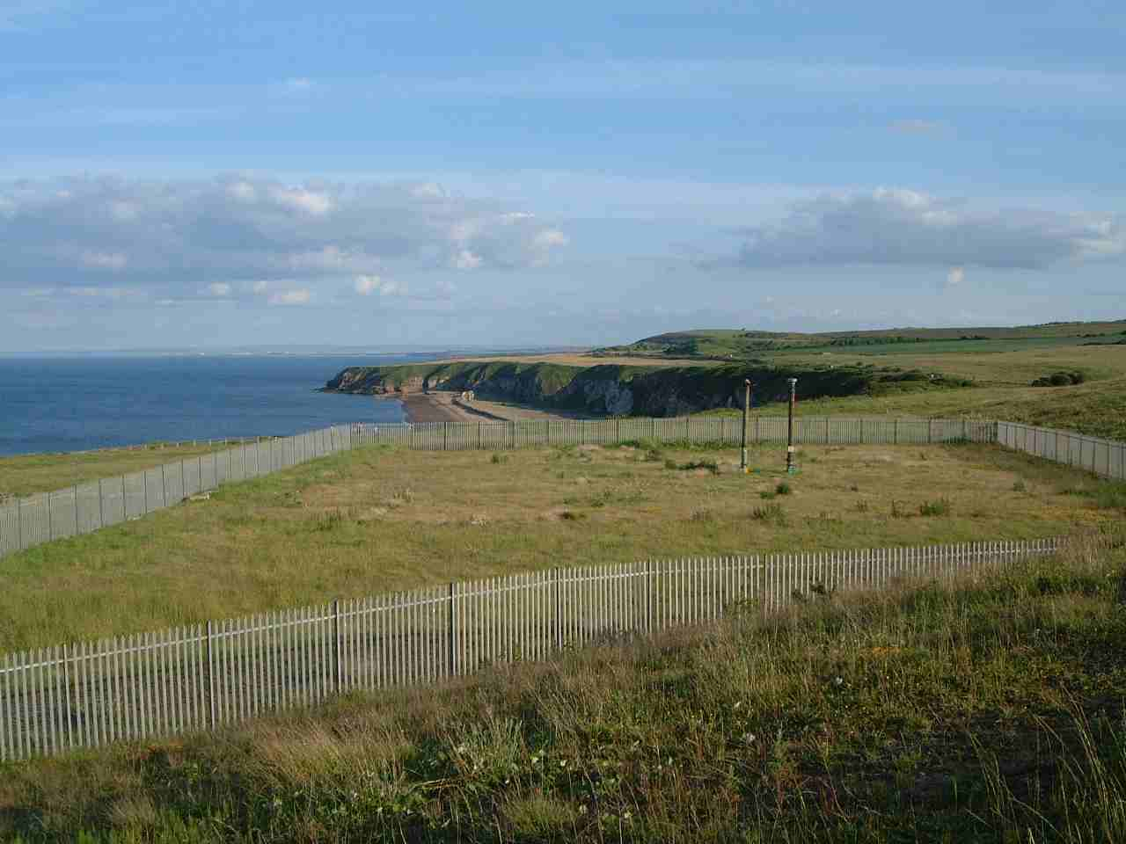  (a)  (b) | 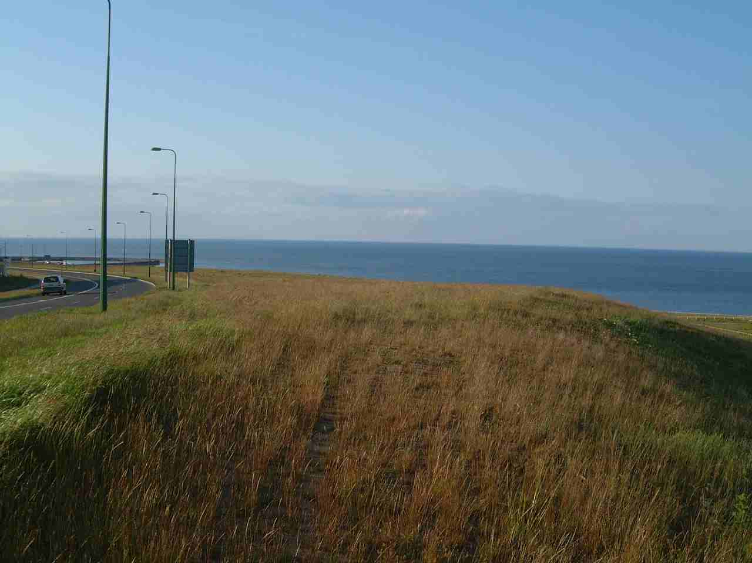

6. Conclusions and recommendations

I have not commented on any of the conclusions and recommendations as all parts have been addressed earlier in the report
A critical assessment of the 'formal risk assessment' [4] which the CA presented to EDC in the form of three reports [1,2,3] has found this assessment to be neither thorough nor reliable. The CA's conclusion that their risk assessment overwhelmingly favours the development of a pump-and-treat system at the Hawthorn site is not borne out by a detailed technical appraisal of their reports [1,2,3]. Rather, if a more comprehensive range of risk factors is taken into account and evaluated, then the Hawthorn site emerges as significantly less preferable to the Dawdon site. Amongst the many reasons why this is so, the following are especially important:
- the Hawthorn Shaft has only two insets, and these are at considerable depth, which means that the water pumped here would likely to be more saline for longer than would water pumped at Dawdon
- the insets at Hawthorn connect to 'horizon' roadways which are effectively cross-measures drifts, which if they were to block are not in close contact with potential bypass flow paths in goaf or via fractured sandstones
- the Hawthorn Shaft is so far west of the coast that it is not possible to be sure that pumping there would either lower water levels sufficiently in the most critical zone (where water levels in the Permian and Coal Measures tend naturally to be closest together, near the coast), or maximise drawdown on the immediate downstream boundaries of critical hydraulic connections to the workings of Easington (and thus to Horden and Blackhall) which are actually present in the Dawdon workings
- pumping at the relatively elevated Hawthorn site will entail lifting mine water 100m higher than at Dawdon, which will result in substantially greater long-term costs for electricity and pipe range maintenance.
- development of a pump-and-treat system at Hawthorn would entail substantial long-term risks associated with a 5km pipeline to the sea carrying saline mine waters; these risk relate both to the inflexibility of having to accommodate an unknown quantity of mine water in a pipeline of fixed diameter, the likely difficulties in getting such a pipeline constructed in time to save the Permian wells from pollution, and the potential for long-term leakage of saline water to the surface environment, with potentially grave consequences for soils, shallow drift aquifers and small streams.
- Development of a pump-and-treat system at Hawthorn is incompatible with proposed land-uses on the rest of the site, and may deter inward investment [9], whereas development of a similar system at Dawdon can probable be rendered compatible with other developments in the area by inclusion of appropriate mitigation measures.

For the reasons given in Section 4, Dawdon is the preferable site on all counts.

It is therefore recommended that EDC:
- refuse approval for the proposed development at Hawthorn, whilst making strong and urgent representations to the CA that the Dawdon site be adopted as the preferred location for mine water pumping and treatment
- take all steps necessary to expedite rapid development of the Dawdon site by the CA
- liaise with Northumbrian Water Ltd and the CA to make sure that precautions are taken to ensure that the continued rise of water levels is not already threatening water supply wells in the district (by the process shown in Figure 1); these precautions might include allowing temporary, partial recovery of water levels in the water wells (by lessening the pumping rate) until pumping from the Dawdon Theresa Shaft has safely lowered the water levels in the old workings below -30mOD.

It is emphasised that time is now of the essence. Extrapolation of the latest rebound records provided by the CA to EDC suggests that water levels are probably already above -30m OD, and are therefore already threatening the public supply wells in the overlying Permian Aquifer. It is essential to brook of no delay in implementing a pump-and-treat solution in East Durham, and the only site where such a development could be undertaken without any risk of fatal delays is Dawdon.

References

- IMC Consulting Engineers, 2001, Durham. Options for the control of mine water east of the River Wear. Draft Report to the Coal Authority (D7208), August 2001. 42pp, plus appendices
- IMC Consulting Engineers, 2002, Options for the control of mine water east of the River Wear - Executive Summary. Report to the Coal Authority (D7247), February 2002. 4pp, plus appendices
- IMC Consulting Engineers, 2002, Durham East of the River Wear Alternative Mine Water Pumping Sites . Report to the Coal Authority (D900714), August 2002. 9pp, plus appendices
- The Coal Authority, 2003, letter to Tony Forster of Easington District Council dated 9th June 2003. 2 pp.
- Younger, P.L., and Adams, R., 1999, Predicting mine water rebound. Environment Agency R&D Technical Report W179. Bristol, UK. 108pp.
- Williams, R., 2001, Pollution of the Permian limestone aquifer by rebounding Coal Measures groundwater, Co Durham, England. Unpublished MSc Thesis, Department of civil Engineering, University of Newcastle. 132pp.
- Younger, P.L., 1995, Hydrogeology. Chapter 11. In Johnson, G.A.L., (Editor). Robson's Geology of North East England. (The Geology of North East England, Second Edition). Published as part of the Transactions of the Natural History Society of Northumbria (Vol 56, (5)). pp 353 - 359.
- Smith, D.B., and Francis, E.A., 1967, Geology of the country between Durham and West Hartlepool. Memoirs of the Geological survey of Great Britain, explanation of one-inch geological sheet 27 (England & Wales), New Series. HMSO, London. 354pp.
- ODPM, 2003, Factors affecting the level and form of private investment in regeneration. Urban research summary No 6. Office of the Deputy Prime Minister, London. 7pp.
- Wood, E.S., 1907, Sinking through the Magnesian Limestone and Yellow Sand by the freezing-process at Dawdon Colliery, near Seaham Harbour, County Durham. Transactions of the Institution of Mining Engineers, 32, pp. 551 - 578.

◻ numbers in square brackets thus: [4] refer to the numbered reference list of documents given at the end of this report.
The Hawthorn Combine was dewatered by pumping at Elemore (580 m³/d), Eppleton (2112 m³/d), and Murton (1345 m³/d).
e.g. a high-density sludge plant, such as the one successfully used for several years now for the highly voluminous mine water discharge at Wheal Jane, Cornwall.

